Visualization assignment
fig 1.
Fig1. Left side shows state 23000. Right side shows state 0. Blue stands for siamang, red stands for orangutan, yellow stands for gorilla, brown stands for human, purple stands for chimp and green stands for bonobo. This visualisation shows how many nodes there are in one glance. While this is just a sketch the amount of surface covered would reflect the “height” of the branch. Hovering with the mouse over a slice would show the complete surface of the circle covered by this color. This is indicated by the stepwise progression in this figure.
0.0657
0.0485
0.0657
0.0657
0.0657
0.0657
0.0485
0.0209
0.0319
0.0485
0.0485
0.0485
0.0319
0.0319
0.0319
0.0209
0.0209
0.0111
0.0111
0.0111
0.051
0.051
0.051
0.0338
0.051
0.051
0.0338
0.024
0.051
0.0338
0.0131
0.051
0.024
0.0131
0.051

Fig2. in this figure, the top part represents state 0 and the bottom part represents state 23000. The arrows represent the branches which in this sketch are not proportional to the given values. It gives a clear impression about the number of nodes. The less nodes, the more compact the tree will become. The numerical values would be added at a branch once the mouse hovers over it/clicks it.
fig 2.
siamang
orangutan
gorilla
human
chimp
bonobo
siamang
orangutan
gorilla
human
chimp
bonobo

Fig 3.
Fig3. Has the endpoints fixed and shared between both states. The black arrows represent state 0 while the red arrows represent state 23000. The length of the arrows will not represent the actual branch length due to the fixed begin and end points. This put’s this figure to a disadvantage compared to figure 1 and 2. On the other hand this figure has the advantage of giving a better comparison from the end points view. Clicking the arrows would return the correct branch length.
siamang
orangutan
gorilla
human
chimp
bonobo

Fig 4.
Fig4. This figure shows a way to compare all states from the endpoint view. The color coding is the same as in the last figures. Each Endpoint is tiered to show level on which the data point splits. The size of each data point represents its branch length relative to the other data points in its tier. The black arrows represent one state. Clicking one of these data points show the state in a similar fashion with the correct branch length next to each connection. This visualization has the advantage that it compares the same endpoints between the different states while still being relatively clean.

Fig 5.
Fig5. This is a relatively simple visualization of the data. It aims to provide a better comparison between the total height of all states. When we scroll down from 1 to 0 the largest trees will appear first and they will sprout at their height on the scale. When we go down further each individual tree will continue growing as branches also scale down. The result provides a forest which ranks trees down from their total height.
The downside is the information lost in this visualization. Branch lengths and significance of endpoints will be lost due to the large amount of data.
1
0

Fig 6.
Fig6. This is a rather standard visualization of tree data. Color coding remains the same as previous figures. Each state has its own tree which sprouts from a central point shared by all states. The advantage is a clear and total representation of the various states. A disadvantage is the bad scalability when using very large data sets. Interactions would include hovering the mouse over a tree to get an enlarged version showing branching nodes and branch values.

Implementation:
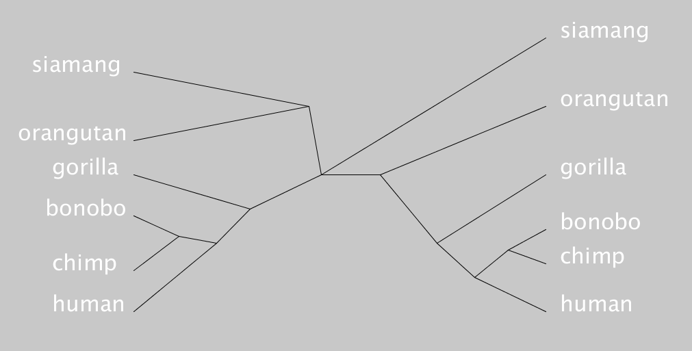
This is a screenshot from the interactive visualization made with processing for state 0 and state 23000. On the left-side we see the branches for state 23000 and on the right side we have state 0. 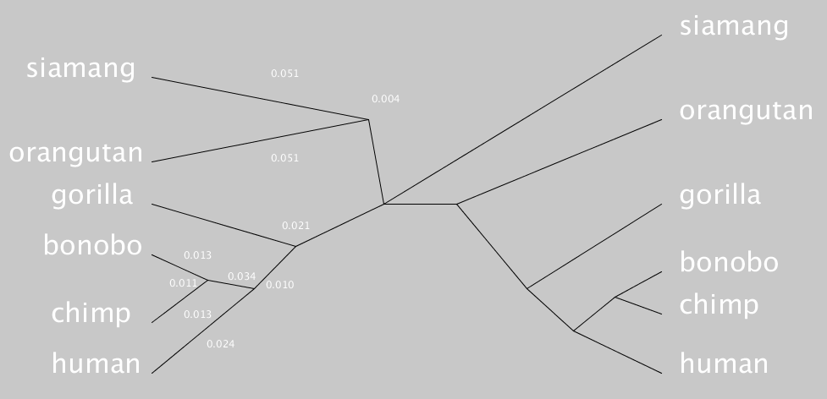
If the left mouse button is pressed the branch values for state 23000 are shown. The ones for state 0 are shown when the right mouse button is pressed. 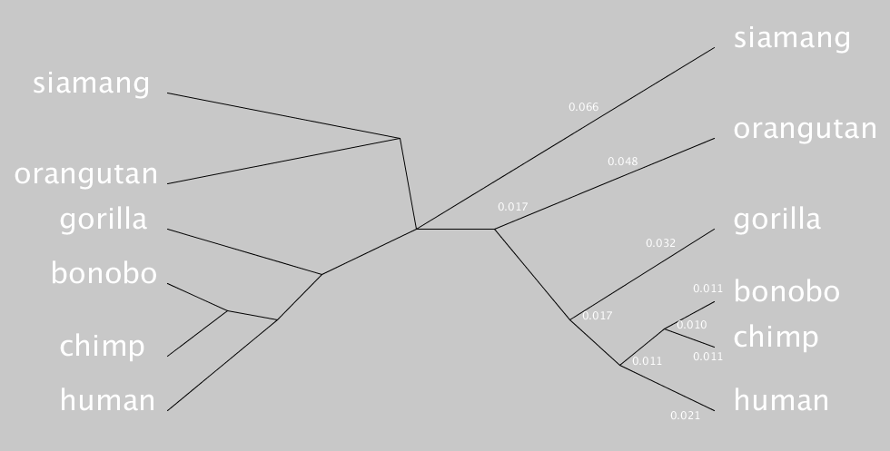

Insights:
While this provides a clear look at the differences between both states the Y value is quite arbitrary and in a further version it would be interesting to either standardize this or exploit it to have even further show differences between the various states. Furthermore, extrapolating this visualization to more than two states provides multiple difficulties. Both the X and Y axis would need to scale in an optimal manner to accommodate for more and more states. Adding a Z axis and forming a Sphere-shaped object could provide a lot more “workspace” to add states. Another problem that might arise with the current form of this visualization is the limitation in endpoints, while theoretically it can accommodate large amounts of endpoints of the trees but in practice this would result in a very colluded and messy visualization which would have little added benefit for the end user.

